***Name:- Raushan kumar Sharma***

***User I’D:- 34745***

***E-mail I’D:-*** [***raushankumarsharma01582000@gmail.com***](http://raushankumarsharma01582000@gmail.com)

***\*\*\*\*\*\*\*\*\*\*\*\*\*\*\*\*\*\*\*\*\*\*\*\*\*\*\*\*\*\*\*\*\*\*\*\*\*\*\*\*\*\*\*\*\*\*\*\*\*\*\*\*\*\*\*\*\*\*\*\*\*\*\*\*\*\*\*\*\*\*\*\*\*\*\*\*\*\*\*\*\*\*\*\*\*\*\*\*\****

**Assignment Topic:-**

**Introduction Powershell cmdlets commands**

Introduction

PowerShell is a task automation and configuration management framework from Microsoft, consisting of a command-line shell and the associated scripting language. PowerShell cmdlets are specialized .NET classes that perform a single function. In this assignment, we will explore basic to intermediate cmdlets with examples. You will run the commands, capture their outputs, and insert screenshots into the placeholders provided.

## Get-Help

Displays help about PowerShell cmdlets and concepts.

Example:  
Get-Help

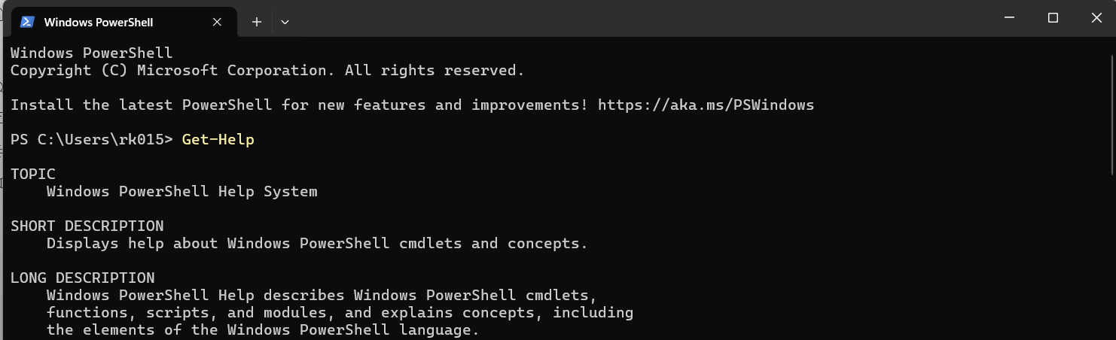

## Get-Command

Lists all available cmdlets and functions in the current session.

Example:  
Get-Command

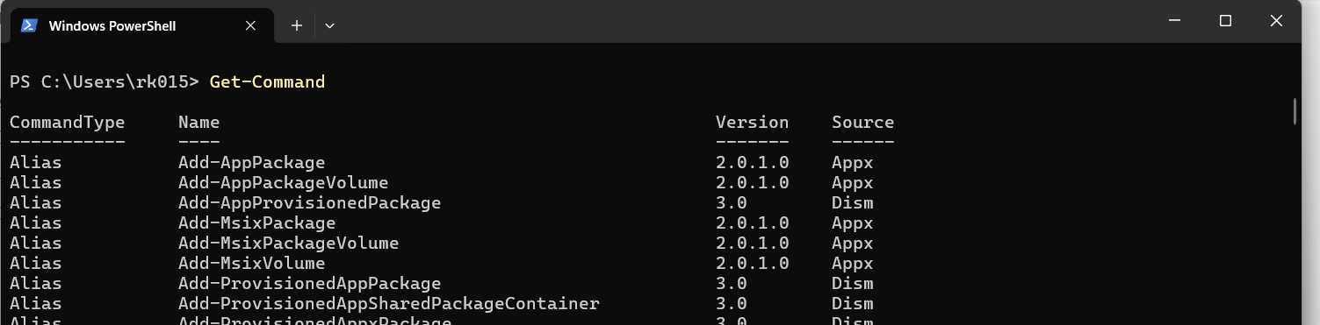

## Get-Member

Shows the members (properties and methods) of an object.

Example:  
Get-Member

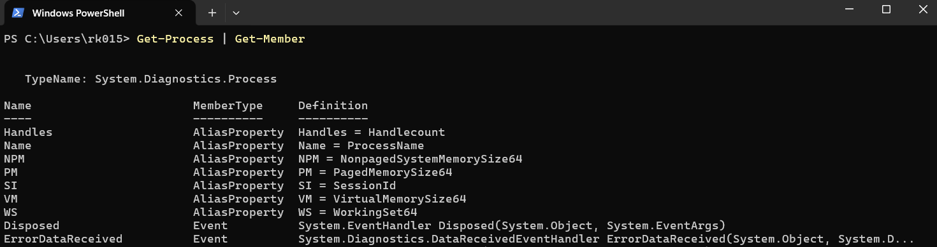

## Clear-Host

Clears the console screen.

Example:  
Clear-Host

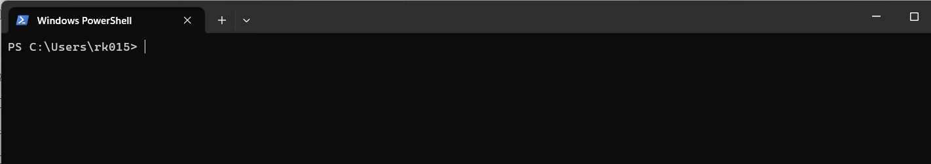

## Get-Alias

Lists aliases for cmdlets and commands.

Example:  
Get-Alias

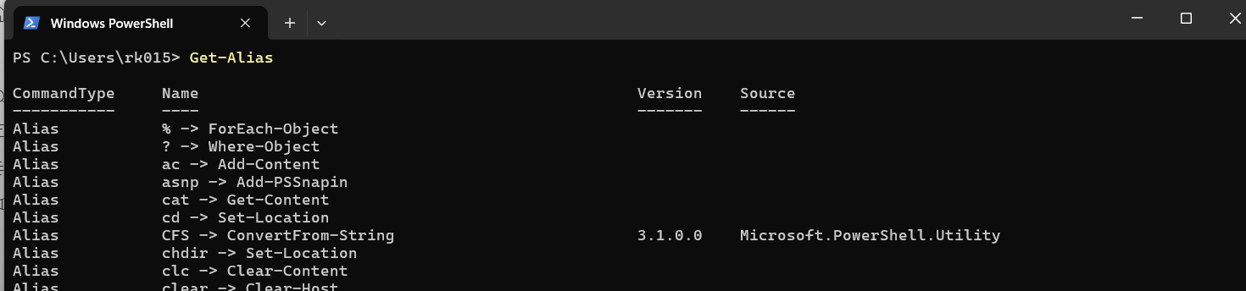

## Get-ChildItem

Lists the files and directories in the current or specified path.

Example:  
Get-ChildItem

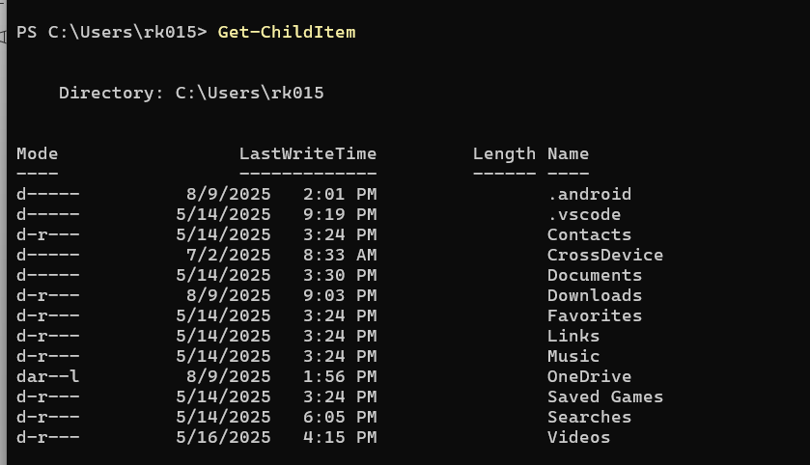

## Set-Location C:\

Changes the current working directory.

Example:  
Set-Location C:\

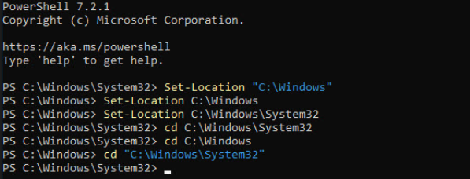

## Format-Table

Formats output as a table.

Example:  
Format-Table

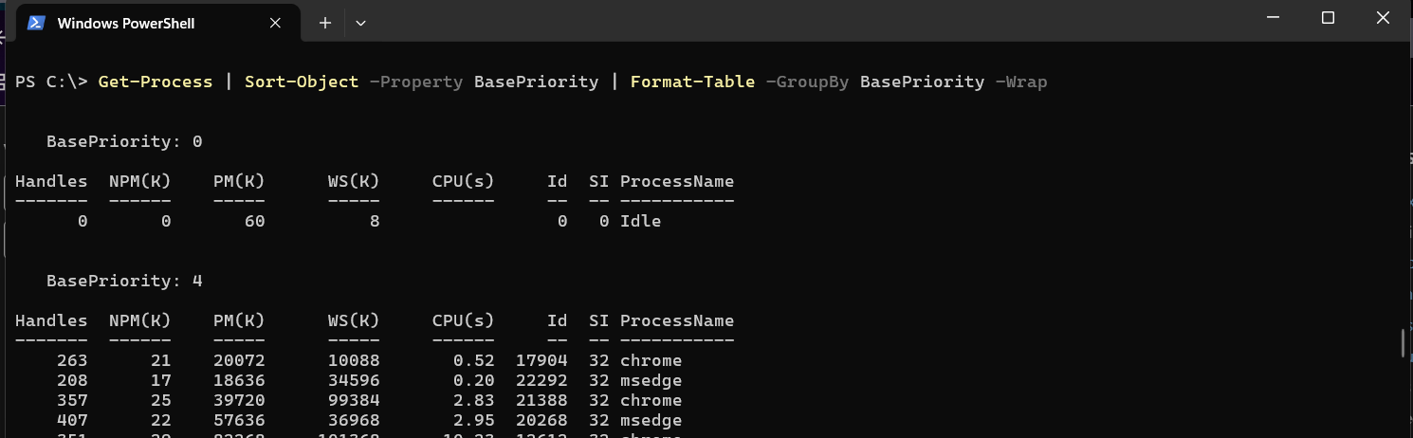

## Get-Process

Lists running processes.

Example:  
Get-Process

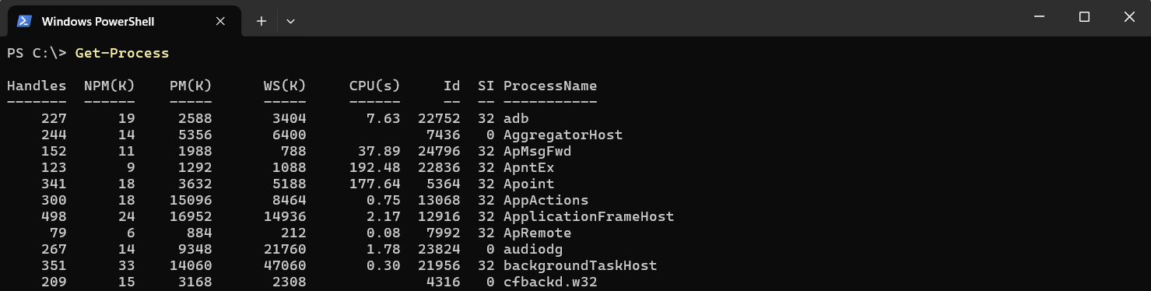

## Stop-Process -Name Zoom

Stops a process by name.

Example:  
Stop-Process -Name Zoom

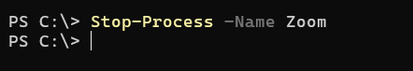

## Get-Service

Lists services and their status.

Example:  
Get-Service

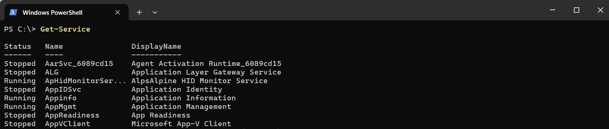

## Start-Service PlugPlay

Starts a stopped service.

Example:  
Start-Service PlugPlay



## Stop-Service SCardSvr

Stops a running service.

Example:  
Stop-Service SCardSvr



## Get-EventLog -LogName System -Newest 5

Displays the newest 5 entries from the System event log.

Example:  
Get-EventLog -LogName System -Newest 5

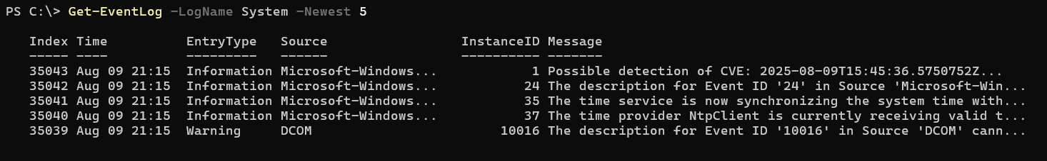

## Where-Object {$_.CPU -gt 100}

Filters objects based on conditions.

Example:  
Where-Object {$_.CPU -gt 100}

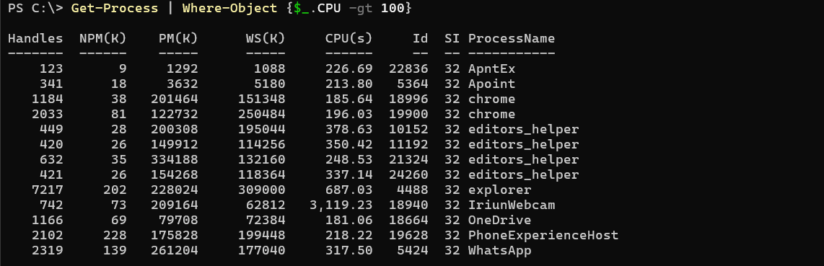

## Select-Object Name, CPU

Selects specific object properties.

Example:  
Select-Object Name, CPU

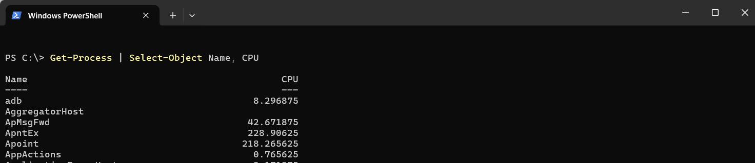

## Sort-Object CPU -Descending

Sorts output by CPU usage in descending order.

Example:  
Sort-Object CPU -Descending

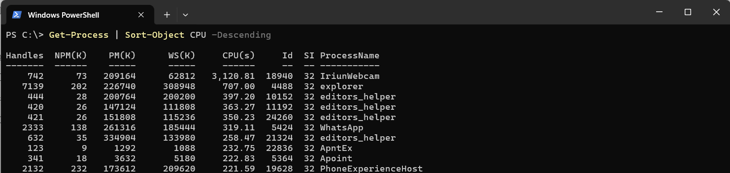

## Measure-Object

Performs calculations on object properties.

Example:  
Measure-Object

